The Vine Tree Concept Solution Research

The Vine Tree is a tiny independent off-license specializing in wine, located in a mixed-use neighbourhood with a sizable college-going population. Although the town has a busy nightlife and a reputation for being a "party town" among the 18-24 age bracket, Joan Lowden, the owner of The Vine Tree, has noticed that her regular customer is older. As a result, she wishes to broaden her clientele to include students to boost foot traffic and sell more wine. This project aims to analyse wine consumption and create a concept based on a wine-tasting festival hosted at a university to attract students.
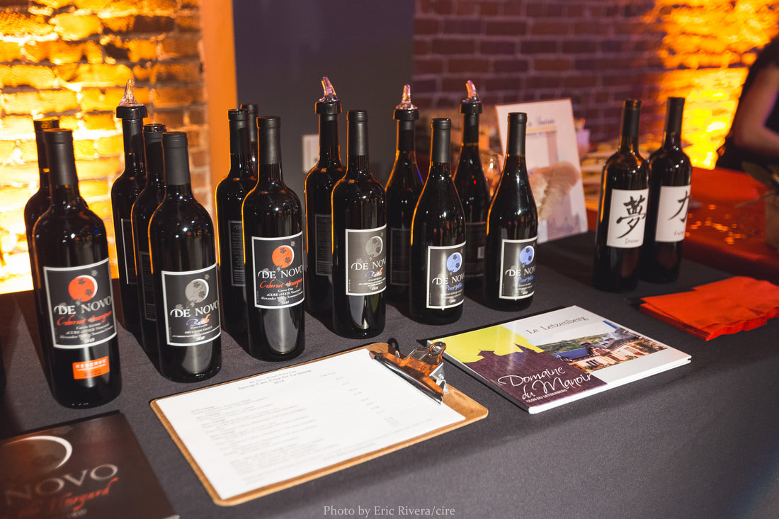

Research:
To discover the greatest opportunity, I must first understand how consumers pick wine, what influences their decision, and why they choose wine over other beverages. According to my research, people buy wine based on a variety of features, including taste, scent, price, brand, and recommendations from friends or experts. Wine may be preferred above other beverages by some people due to its health advantages, cultural importance, or social standing. However, the 18-24 group may not have a strong liking for wine or may be unfamiliar with it, making it difficult for The Vine Tree to attract them.
I also discovered that the group examined (18-24-year-olds) makes beverage purchase decisions based on various factors, including price, availability, convenience, and social norms. When attending BYOB gatherings such as barbecues or home parties, they may select cheap, easy-to-transport, and popular beverages among their peers. Wine may not be their first choice, particularly if they view it to be costly, pompous, or difficult to enjoy in a social context.

I produced the following HMW (“How Might We…”) statements based on my research:
- How might we make wine more attractive to the 18-24 age group?
- How might we promote wine knowledge and awareness within the 18-24 age group?
- How might we build a social wine experience that appeals to the 18-24 demographic?
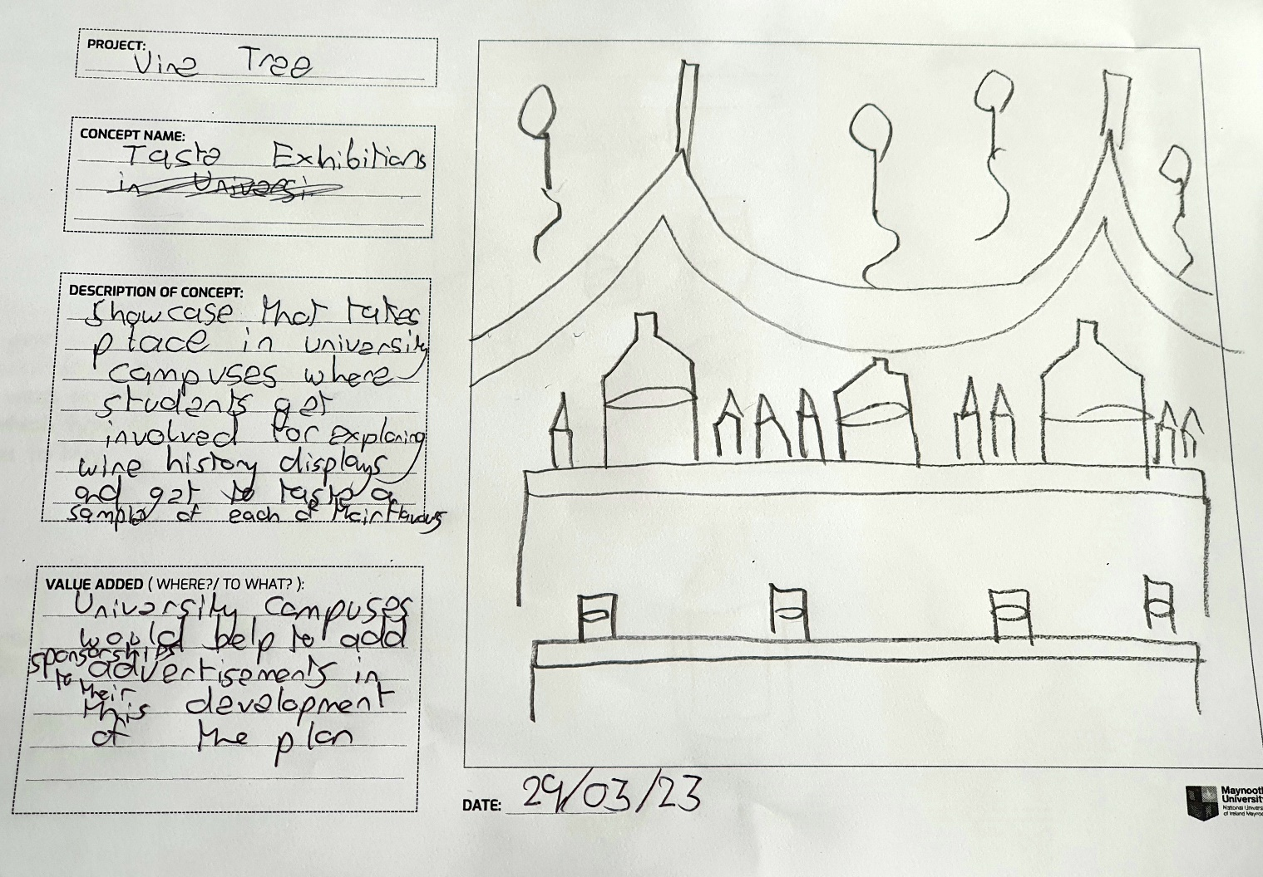

Concept:
Based on my findings, I suggest a wine-tasting festival carried out at a university to attract students and modify their view of wine. The festival would be held on a Saturday afternoon during the students' spare time and would feature a range of activities aimed at making wine more enjoyable, accessible, and inexpensive.
- The festival will be held on a university campus or a nearby location that is easily accessible to students. The venue will have an outdoor or indoor space that can accommodate many people.

- The event would include wine tastings, where the younger demographics may sample various wines, learn about their preferences, and discover new favourites. It will also feature educational sessions on wine tasting, food pairing, and the history of wine. The tastings would be led by wine specialists, including Joan Lowden herself, who could offer advice and answer any questions the students had. There will also be food matching stations where students could try different cuisines and discover which wines go best with them.

- To make the festival more convenient and affordable, I suggest a token system in which students may buy tokens that can be exchanged for wine tastings and food pairings. The tokens would be moderately priced, allowing students to sample various wines and delicacies without breaking the budget. Furthermore, to encourage sales, I recommend granting discounts to students who buy tokens in advance or in bulk.

- It’s recommended to integrate other activities, such as live music, games, and competitions, to make the event more enjoyable. We might, for example, hold a blind wine-tasting competition in which students may earn prizes for properly recognizing various wines. We might also hold a social media contest in which students may share their festival experiences on social media with a specific hashtag and win prizes for the most innovative postings.

- The festival will have a strong social media presence, promoting the event, sharing images and videos, and interacting with participants on sites such as Facebook, Instagram, and Twitter. The Vine Tree will also use social media before and after the event to interact with the 18-24 demographic, creating a community of wine aficionados who can share their experiences and suggestions.

- The Vine Tree will partner with local wineries, wine experts, and food vendors to provide a diverse range of wines and food pairings. The partners will have booths or stalls where they can showcase their products and engage with the attendees.

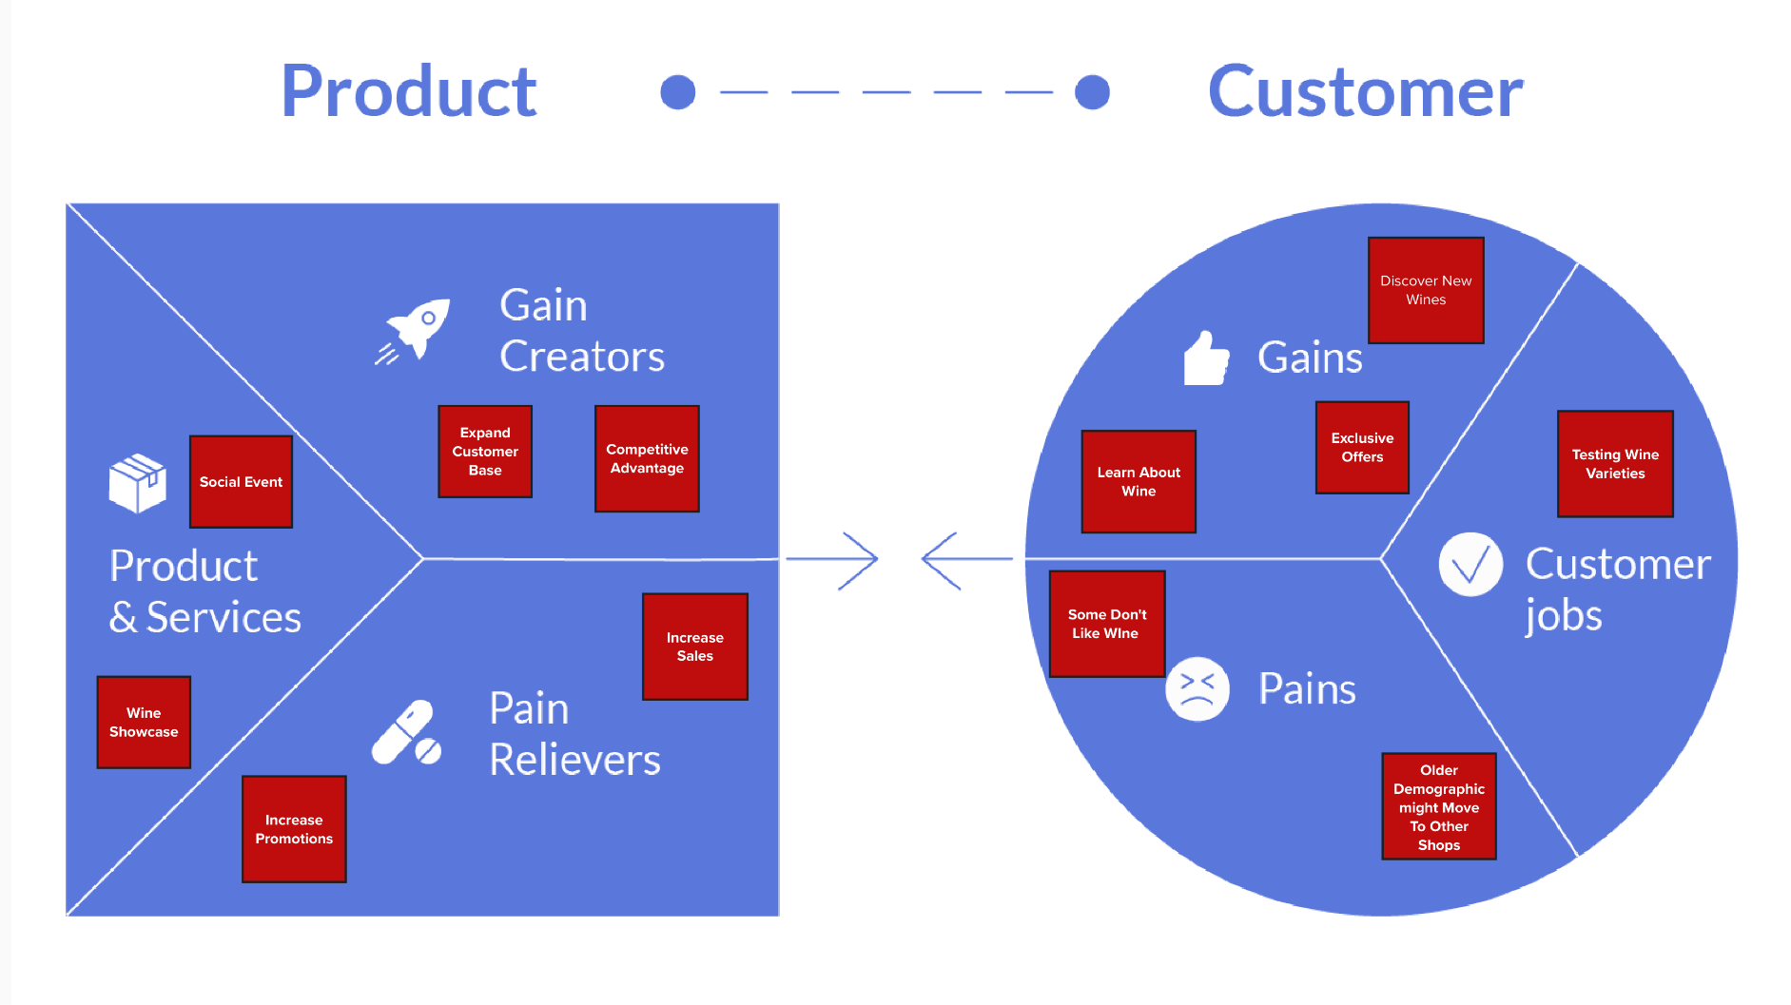
Value Proposition Diagram:

The value proposition diagram shows the advantages of The Vine Tree's Wine Tasting Festival idea for both The Vine Tree and university students. The event allows The Vine Tree to establish itself from other off-license merchants in the region and exhibit its wine knowledge.
The event gives university students a chance to learn more about wine and the wine-making process. Additionally, it offers the chance to sample several wine varieties and learn about food matching. Students will get vouchers for savings on wine purchases at The Vine Tree that may be redeemed at the event, which is free to attend.
The wine-tasting festival on the university campus would be an effective way for the Vine Tree to engage with the 18-24 demographic and increase footfall to their store. By showcasing its expertise in wine and offering exclusive discounts to festival attendees, the Vine Tree can position itself as the go-to destination for wine purchases in the area. The event also gives a chance for The Vine Tree to recruit and grow sales among the 18-24 age bracket. Some down points would be losing some older customers loyal to this brand and moving to other businesses as product prices for their age are more expensive while some just don’t want to attend as they’re never into wine.

Journey Map (Service Blueprint):
- Pre-event Promotion: The Vine Tree might use social media channels such as Facebook, Twitter, and Instagram to advertise the wine-tasting festival at the university. The advertising materials should be aesthetically appealing and aimed at those aged 18 to 24. The advertising should include the date, time, location, and details about what will take place during the event.
- Organizing the Event: The Vine Tree crew will set up the wine sampling stations on the university campus on the day of the event. They'd set up a table with wine glasses and spittoons, as well as wine information like grape variety, origin, taste notes, and meal combinations.
- On-site Experience: Upon arriving at the festival, attendees can check in and receive a map of the different stalls. They can then explore the different stalls, learn about different wines, and participate in wine-tasting classes.
- Wine Tasting Experience: Students attending the event will be able to sample several wines chosen by the Vine Tree team. The team members would be on hand to provide wine knowledge and answer any queries. There would also be an opportunity to acquire the wines at a reduced price.
- Purchase: The Vine Tree can provide attendees with the option to purchase their favourite wines at the event. They can also provide discount vouchers to encourage attendees to visit their off-license location.
- Social Media Interaction: The Vine Tree would encourage students to use hashtags and tag The Vine Tree's social media handles when posting about the event on social media platforms. This will aid in the distribution of information about the event and The Vine Tree's unique offers.
- Post-Event Engagement: Following the event, The Vine Tree may continue to communicate with participants by sending out newsletters and social media updates, marketing their goods, and providing valuable wine resources.

Test Script:
To put the idea of a wine-tasting festival to the test, we may run a survey among local college students to measure their interest in attending such an event. This data could be analysed to refine the event, improving it for the next iteration. We may also do focus group sessions to learn about the exact features that people want to see in the event. Based on the input, we may improve the festival's design and marketing strategy to appeal to the target population. The final plan may then be tested by staging a trial event and tracking its performance in generating footfall and revenue at The Vine Tree.

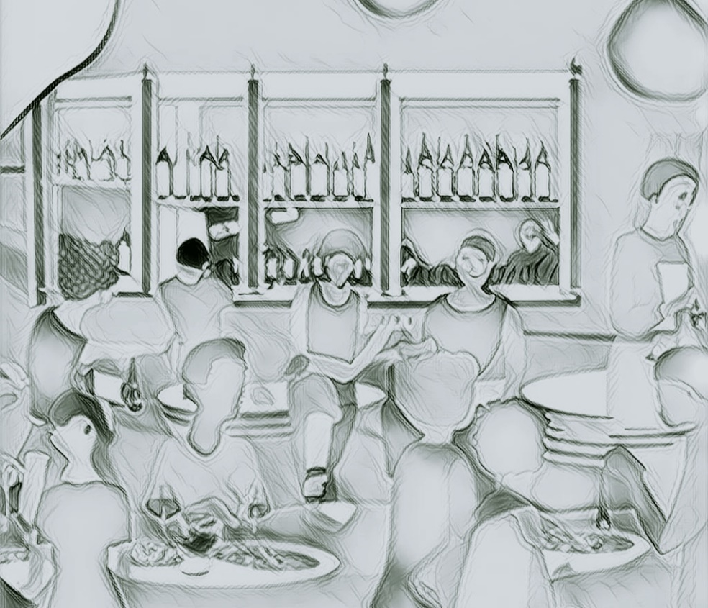
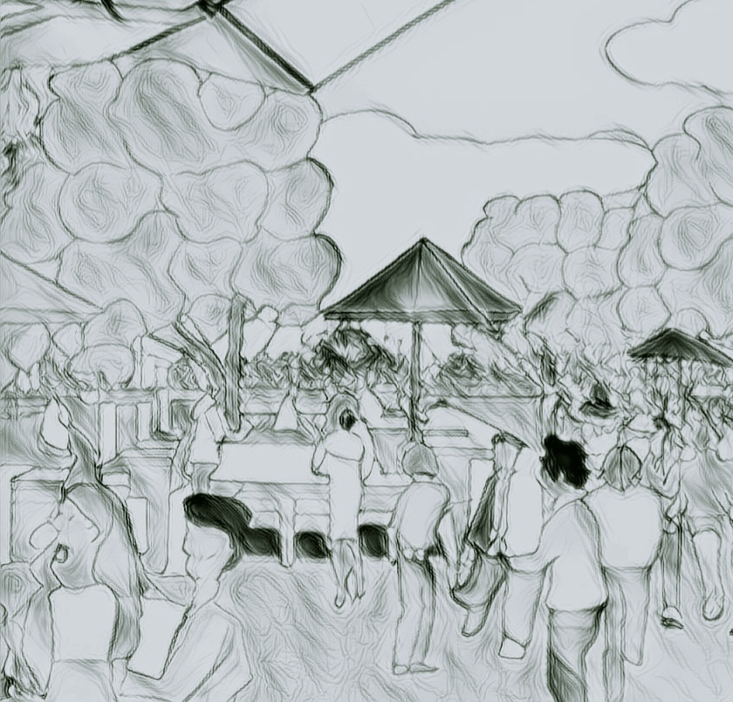
Rough Sketches of a Possible Prototype of the Concept

